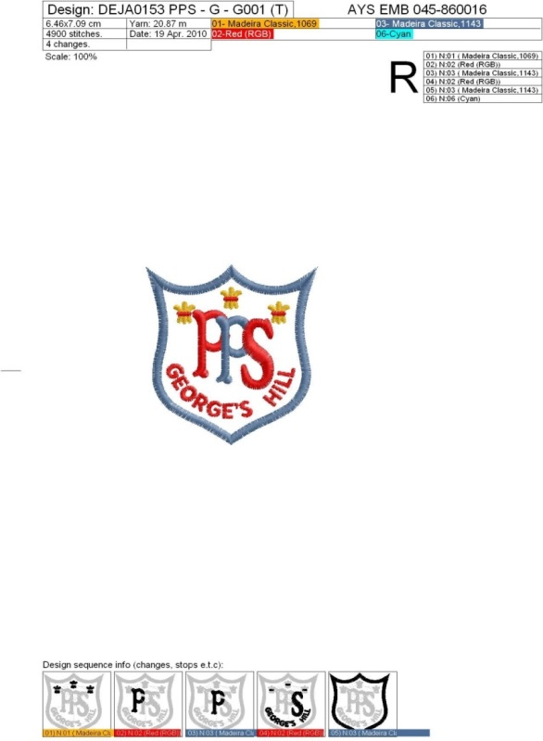
PRESENTATION PRIMARY SCHOOL, GEORGE’S HILL

ENROLMENT FORM – EARLY INTERVENTION/ASD UNITS
SEPTEMBER 2025
Closing Date for Applications is 31st JANUARY 2025
Late Applications will be placed on a waiting list
DATE: _________________
Child’s First Name: __________________ Surname: ________________ Gender: _________
Address: _____________________________________________________________________
___________________________________________ Eircode: _________________
Date of Birth: ___________________________ P.P.S. Number: ____________________
Child’s Nationality: _______________________ Child’s Religion: ____________________
Siblings in the School: __________________________________________________________
Languages Spoken at Home – 1: _______________________________
2: _______________________________

Mother/Guardian’s Name: _____________________________________________
Mother/Guardian’s Nationality: _________________________________________
Father/Guardian’s Name: _____________________________________________
Father/Guardian’s Nationality: _________________________________________
N.B. Please state if your child suffers from any allergies or medical conditions
_________________________________________________________________________
_________________________________________________________________________
Does your Child have any Psychological Assessments or Reports: ____________________
Social Worker or other Agency: ________________________________________________
Name of previous School/Playschool: ___________________________________________

-------------------------------------------------------------------------------------------------------------------------------
For Office Use:
Date of Admission: ________________ Roll No: ___________ Birth Cert: ________
CONTACT DETAILS 2025/2026
Name of Child | Address | Home Phone No.

Mother’s Mobile Number
Email Address

Father’s Mobile Number
Email Address

EMERGENCY PHONE NUMBERS
(These numbers must be different from the numbers above)
1. Name | Mobile Number | Home Number
2. Name | Mobile Number | Home Number

** N.B. Please mark below if your child suffers from any Allergies or Medical Conditions
YES □ NO □
If yes, please state clearly the allergy or medical condition
_____________________________________________________________________________
I agree to the School’s Code of Positive Behaviour and Admissions Policies and will adhere to same. (Policies are available on www.georgeshillschool.ie and in the school office)
I give permission for samples of my child’s work to appear on the School Website
I give permission for photographs of my child to appear on the School Website

Signed: ________________

