Cheese Chicken Mushrooms and Spinach puff pastry tart

Half a pack of ready roll puff pastry Handful of spinach leaves

Half a ball of mozzarella sliced Two sliced mushrooms

Handful of chopped chicken

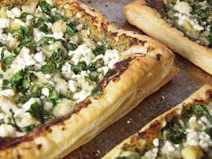

1. Score puff pastry with fork
2. Layout cheese evenly on pastry leaving sides free
3. Lay some spinach over cheese
4. Evenly spread out some chicken
5. Evenly spread out some mushrooms
6. Bake for about 20minutes until golden brown
7. Slice up and share with others.