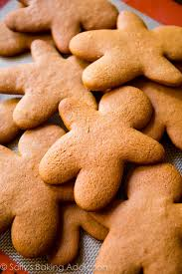
Gingerbread recipe

175g of plain flour 1 egg
1 teaspoons ground ginger 75g butter
85g brown sugar 2 tablespoons of water.
2 tablespoons of golden syrup 1 teaspoon bicarbonate soda

Equipment
Sieve, bowl, rolling pin, baking tray

- Sieve the flour and bicarbonate soda into a bowl and mix up well to add air.
- Add butter and with fingertips make a breadcrumb like mixture.
- Add in sugar mix well.
- Add egg and golden syrup into mixture mix in.
- Add in water and mix up to make a ball of dough.
- Knead mixture on floured surface add more if needed.
- Roll out mixture and use cutters of your choice to make gingerbread.
- Put gingerbread on floured baking sheet and bake for about 10-15 mins at 170 degrees.
- Take out gingerbread when it is golden brown.

